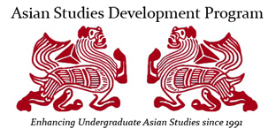
Presents

Chinese Identities and Expressive Cultures:
Traditions and Transformations

Trident Technical College, Palmer Campus Amphitheater
66 Columbus Street, Downtown Charleston

Friday, October 21, 2016
8:45-9:00 Introductions

9:00-10:00 Peter Hershock, ASDP “Realizing Personhood in Community: Chinese Ideals of Responsive Virtuosity”

10:00-10:15 Coffee Break

10:15-11:45 Bonnie Cheng, Oberlin College “Contemporary Chinese Art”

11:45-12:45 Lunch for Registered Participants at Mercantile and Mash

12:45-1:45 Fred Lau, University of Hawai’i at Manoa “Music and Contemporary Chinese Culture”

1:45-2:00 Break

2:00-3:00 Kun Qian, University of Pittsburgh “Contemporary Chinese Literature and Film”

3:00-4:00 Yang Guobin, University of Pennsylvania “Contemporary Chinese Society”

4:00-4:15 Break

4:15-5:00 Panel Discussion and Close

For more information, please visit http://www.tridenttech.edu/about/departments/ttc_global.htm or contact the TTC International Education Office at 843-574-6457
To register, please go to http://events.egov.com/eventreg/SC/event.htm?name=chineseidentities

